EduAccess Resource Bridge
EduAccess Resource Bridge is a peer-to-peer marketplace and donation platform designed to connect individuals who have surplus educational resources with students who lack access to them. The platform aims to reduce educational inequality by enabling the redistribution of textbooks, study materials, devices (such as laptops and calculators), and other academic essentials.
Problem Statement
High-quality educational materials and physical resources such as textbooks, reference guides, and laptops are often discarded or left unused by graduates. At the same time, many underprivileged students struggle to access these resources due to financial limitations. This imbalance leads to unnecessary waste on one side and lack of opportunity on the other.
Proposed Solution
EduAccess Resource Bridge provides a structured and accessible digital platform where users can:
- Donate unused educational materials
- Sell or exchange academic resources at affordable prices
- Request specific learning materials
- Connect directly with peers in a secure environment
By facilitating direct peer-to-peer interaction, the platform ensures transparency, accessibility, and efficient resource redistribution.

System Design
The system connects donors (graduates) and students through a centralized digital platform where educational resources can be listed, searched, requested, and delivered.
The application follows a 3-layer architecture:
1. Presentation Layer (Frontend)
Handles user interaction.
Functions:
- Registration & Login
- Upload resource form
- Search interface (location-based)
- Request tracking dashboard
2. Application Layer (Backend Server)
Handles:
- Authentication & Authorization
- Business logic
- Request validation
- Status updates
- API communication
- Location filtering logic
3. Data Layer (Database)
Stores structured data:
Tables:
- Users
- Inventory (Items)
- Requests
- Logistics
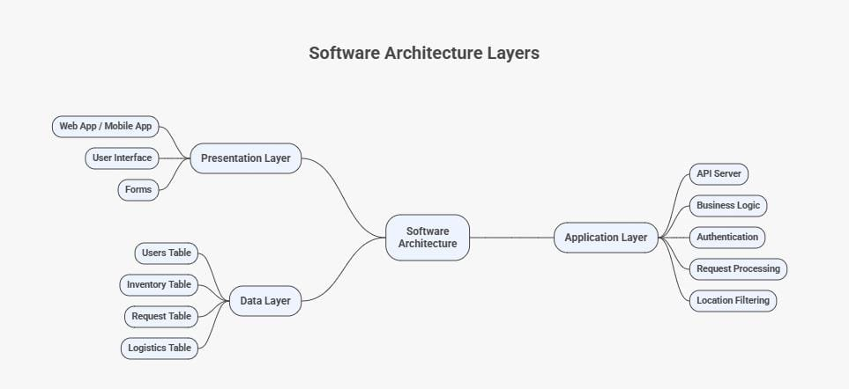

Application Work Flow
Step 1: User Registration
- User selects role (Student / Donor)
- Enters name, email, password, location
- Backend validates:
- Email uniqueness
- Required fields
- Data stored in Users table
- Account created
Step 2: Login & Authentication
- User enters credentials
- Backend verifies using secure password hashing
- Session / JWT token generated
- Dashboard loaded
Step 3: Donor Uploads Item
- Donor fills form:
  - Title, Category, Condition, Image, Location
- Backend:
  - Validates input, Stores in Inventory table, Sets status = "Available"
Now item is searchable.
Step 4: Student Searches Item
- Student enters:
  - Location, Category
- Backend:
  - Queries Inventory table
  - Filters:
    - location
    - status = Available
- Returns list of nearby items
Step 5: Student Requests Item
- Student clicks "Request"
- Backend:
  - Checks item availability
  - Creates record in Requests table
  - Updates item status = Requested
- Donor notified
Step 6: Donor Approves Request
- Donor views request
- Clicks Approve
- Backend:
  - Updates request_status = Approved
  - Updates item status = Approved
  - Generates tracking_id
  - Creates record in Logistics table

Step 7: Logistics & Tracking
- Logistics partner receives pickup details
- Updates delivery status
- Student sees tracking updates in dashboard

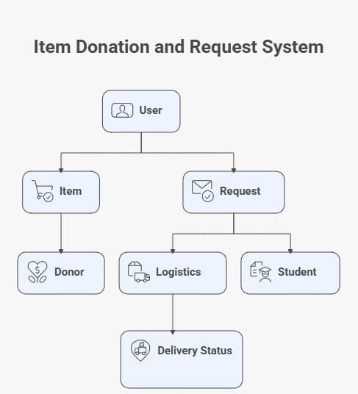
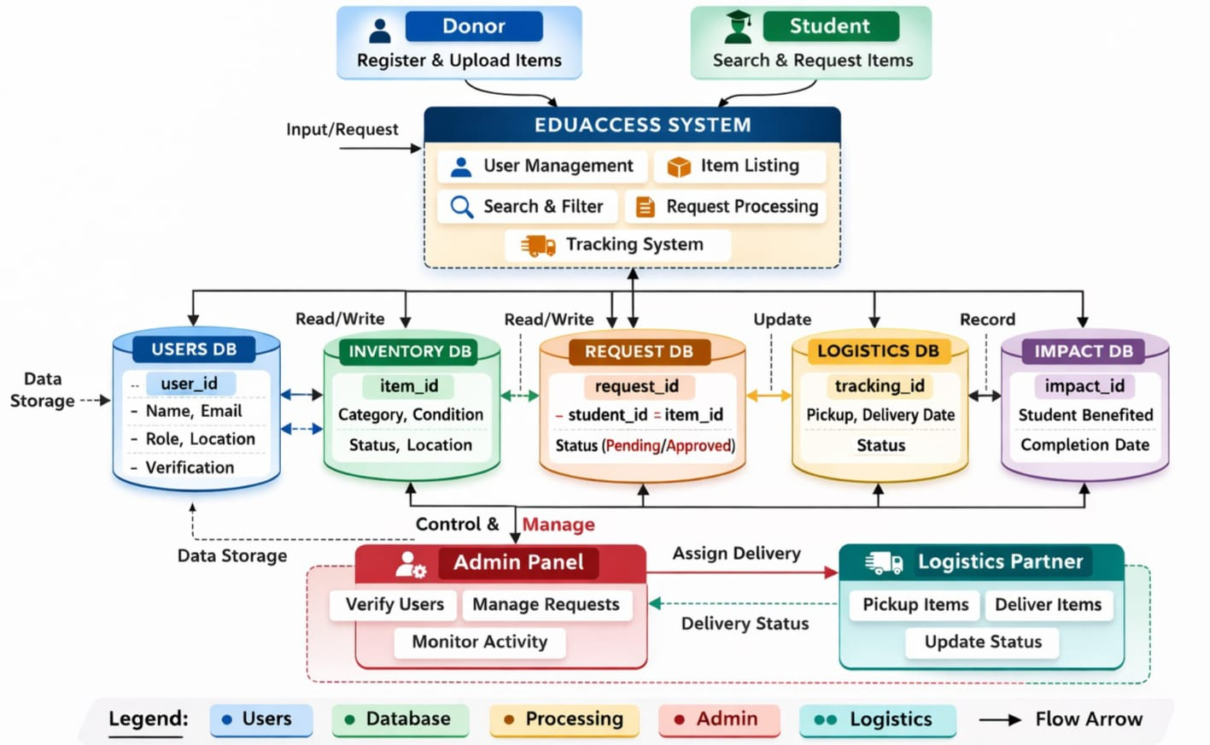
Data Flow

The Data Flow Diagram (DFD) of the EduAccess System represents how data moves between users, system processes, databases, the admin panel, and the logistics partner. It clearly shows the interaction between external entities and internal components while maintaining structured data storage and processing.
At the top level, the system has two primary external users: Donor and Student. The Donor registers and uploads items, while the Student searches and requests items. Both users send input requests to the central EduAccess System, which acts as the core processing unit. Inside this system, key functional modules include User Management, Item Listing, Search & Filter, Request Processing, and the Tracking System. These modules handle all business logic before interacting with the databases.
The system stores and retrieves data using five main databases. The Users Database stores user details such as name, email, role, location, and verification status. The Inventory Database stores item-related information including item ID, category, condition, status, and location. When a student places a request, the system creates a record in the Request Database, which tracks request ID, associated student and item, and request status (Pending or Approved). Once approved, delivery details are stored in the Logistics Database, which maintains tracking ID, pickup and delivery dates, and delivery status. Additionally, the Impact Database records project outcomes, such as the number of students benefited and completion dates, supporting impact analysis and SDG reporting.
The Admin Panel acts as a control layer. The admin verifies users, manages requests, and monitors platform activity. The admin can also assign deliveries to the logistics partner. The Logistics Partner receives pickup instructions, delivers items, and updates delivery status, which is reflected in the Logistics Database and visible to students through the tracking system.
Overall, the data flows from users to processing modules, then to structured databases, and finally back to users through status updates and tracking information. The diagram ensures separation of concerns, controlled database access, and a clear lifecycle from item listing to final delivery and impact recording.

Impact on SDG 4 – Quality Education
The EduAccess Resource Bridge project directly contributes to SDG 4: Quality Education, which aims to ensure inclusive and equitable quality education and promote lifelong learning opportunities for all. One of the major barriers to quality education is unequal access to essential learning resources such as textbooks, reference materials, laptops, and other academic tools. While many graduates discard or underutilize these resources after completing their studies, underprivileged students often struggle due to lack of access.
Our platform bridges this gap by creating a peer-to-peer donation and resource-sharing ecosystem specifically designed for educational materials. By enabling donors to list items and students to search and request them based on location, the system reduces financial burden and improves accessibility. The location-based search feature ensures resources are efficiently redistributed within communities, minimizing logistical barriers.
Additionally, the project promotes sustainability by encouraging reuse instead of disposal, thereby supporting responsible consumption practices alongside educational equity. By improving access to academic materials, the platform enhances learning outcomes, supports digital inclusion, and empowers economically disadvantaged students to continue their education without resource constraints.
Thus, EduAccess Resource Bridge strengthens educational inclusivity and advances the objectives of SDG 4 in a practical, technology-driven manner.

